**BLCC 6.0 Summary**

BLCC is being transitioned to a web application. Below is a brief comparison of the current BLCC 5.3 software and the current BLCC 6.0 mock interface. The mock interface is simply a visual representation of the tool layout. It is not functional and is being used solely to review the general design. A demo will be provided that walks through what the capabilities will be once completed. For each group of images, the first is of BLCC 5.3 and the second is of BLCC 6.0 mock interface.

The general layout of the tool is similar, with navigation throughout a project’s information on the left-hand side and access to common “File” actions, help, and results in the header. All the information provided/requested in BLCC 5.3 is also in BLCC 6.0, although there will be some changes on where that information is located. Additionally, there will be additional information provided/requested that will highlighted throughout this document.

**General Information Page** includes the general project information including location and discounting assumptions. BLCC 6.0 will add information for energy-related GHG emissions rates and social cost of GHG emissions. These will be based on federal sources of data and any federal guidance. Instead of user tips provided at the bottom of each screen, BLCC 6.0 will provide tool tips (not shown) when you scroll over an item as well as information icons (not shown) can be selected to get a pop-up of additional explanation for the item. Additionally, we will provide errors/warnings for unexpected or unrealistic values. We have found these to be user friendly features in our new web tools.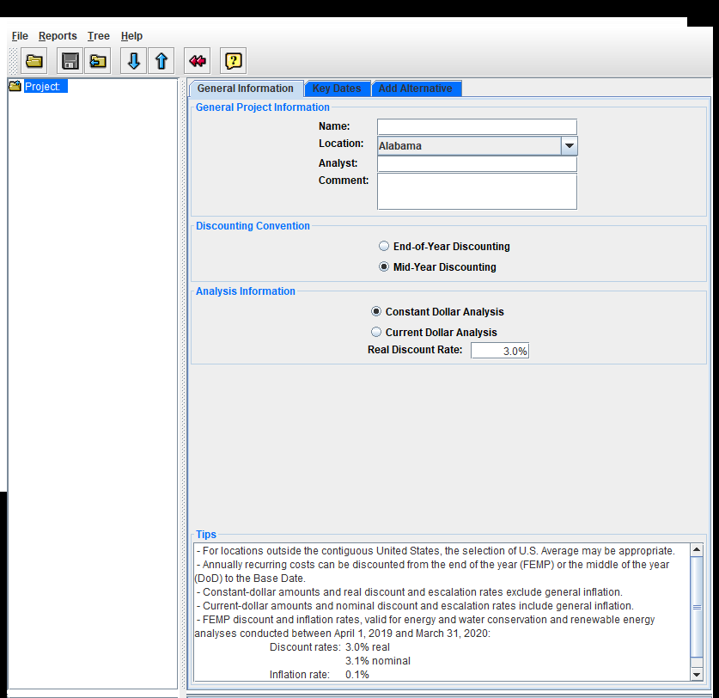 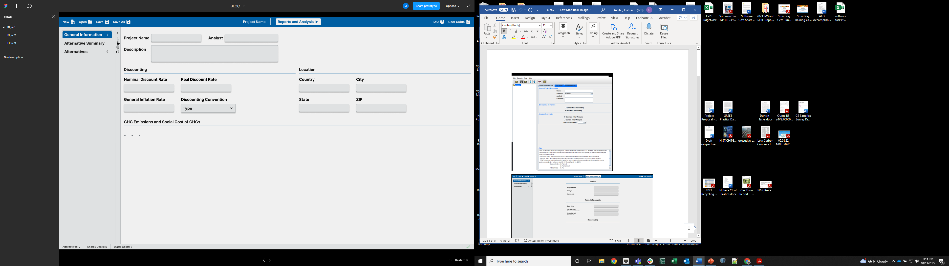

**Alternative Summary Page** does not exist in BLCC 5.3. The most comparable is the content shown when the user clicks on the “Project” folder on the left, where you can select “Add Alternative”. The Alternative Summary Page allows a user to quickly see a summary of each alternative and can click on an alternative to see that specific alternative’s page. A user can also add an alternative here, which can be started from scratch or create a copy of an existing alternative. Note that the user must select a Baseline Alternative to be used for any comparative analysis.

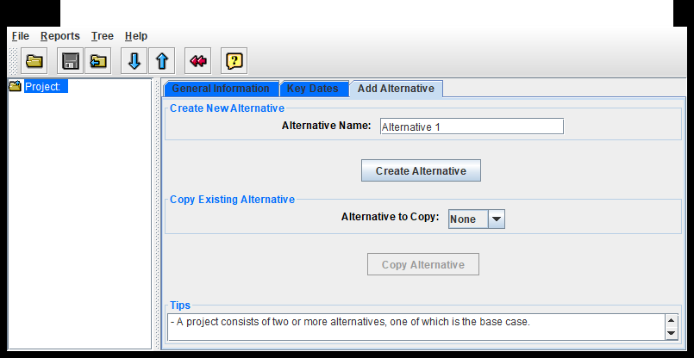

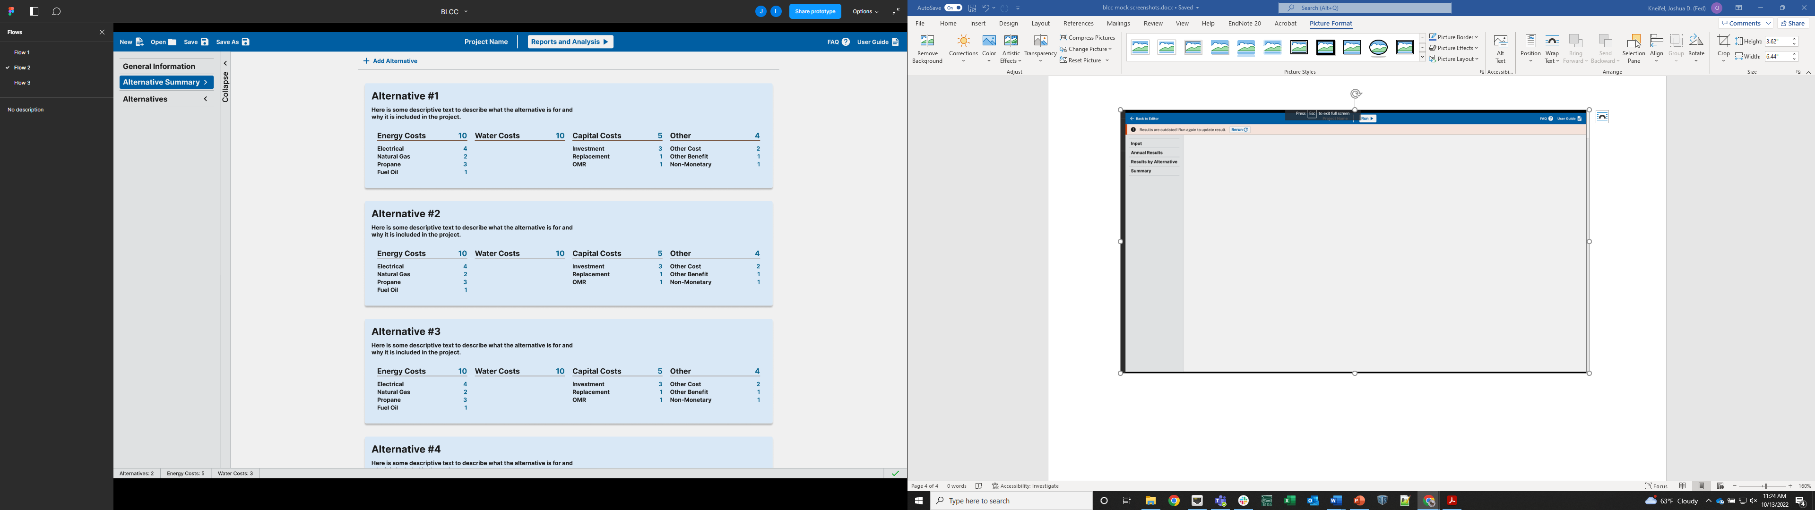

In BLCC 5.3, a user could only navigate through an alternative by using the folder structure on the left-hand side. This navigation is updated to that in the second image, where a user can select an alternative and see all the costs by category. Additionally, by selecting an alternative, the page updates to that **Alternative’s Page**. To see a specific cost, the user can either click on the cost in the navigation pane on the left or on the cost on the alternative’s summary page. Note that BLCC 5.3 does not provide the summary of the costs in that alternative on the page and you have to navigate to costs using the left-hand folder structure. Note that we have added a “Other” cost/benefit category that can be used to capture costs that do not fit into the typical BLCC categories.

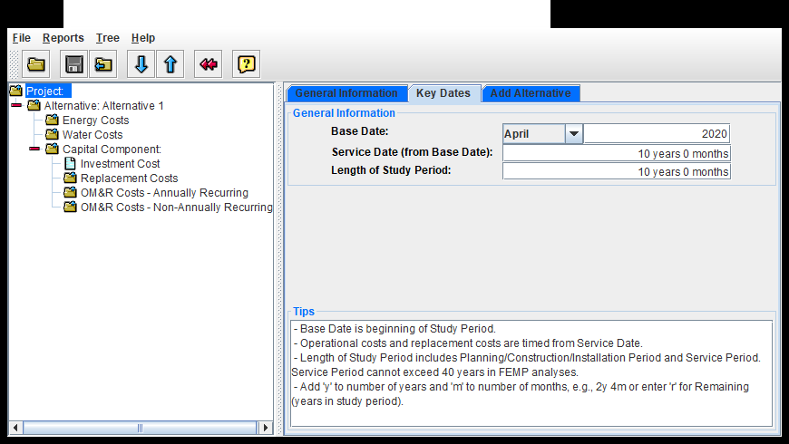

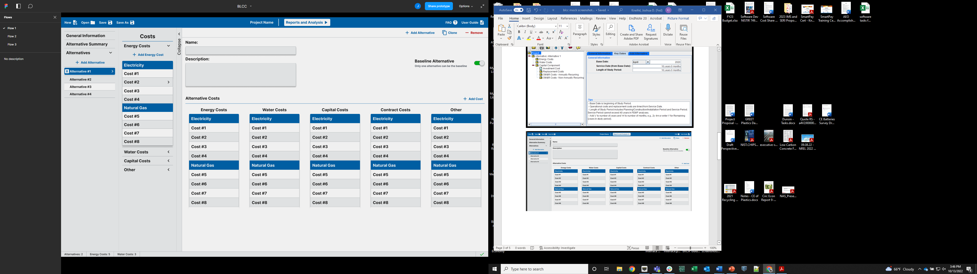

Once a user selects a specific cost, it will take you to that **Specific Cost Page.** Shown here is an example of electricity costs. Note the difference in the page structure. BLCC 5.3 requires populating of information on two separate tabs within the page (Energy Usage and Energy Cost) while BLCC 6.0 provides all the inputs on a single page. Additionally, the emissions rate selection was removed because they will be based on the location provided on the **General Information Page**. Users can also quickly change or add the cost to other alternatives, copy the current cost for modification, or create a new cost of the same type from scratch.

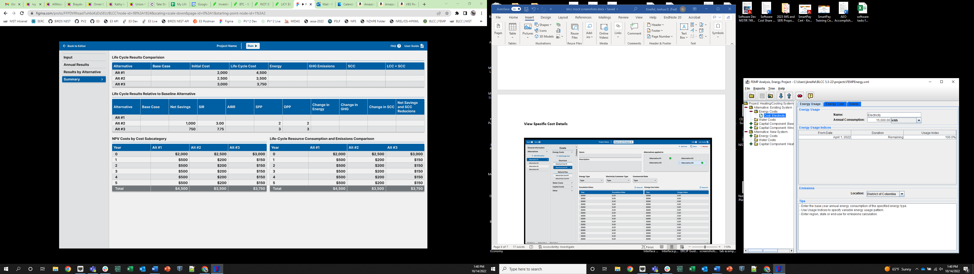

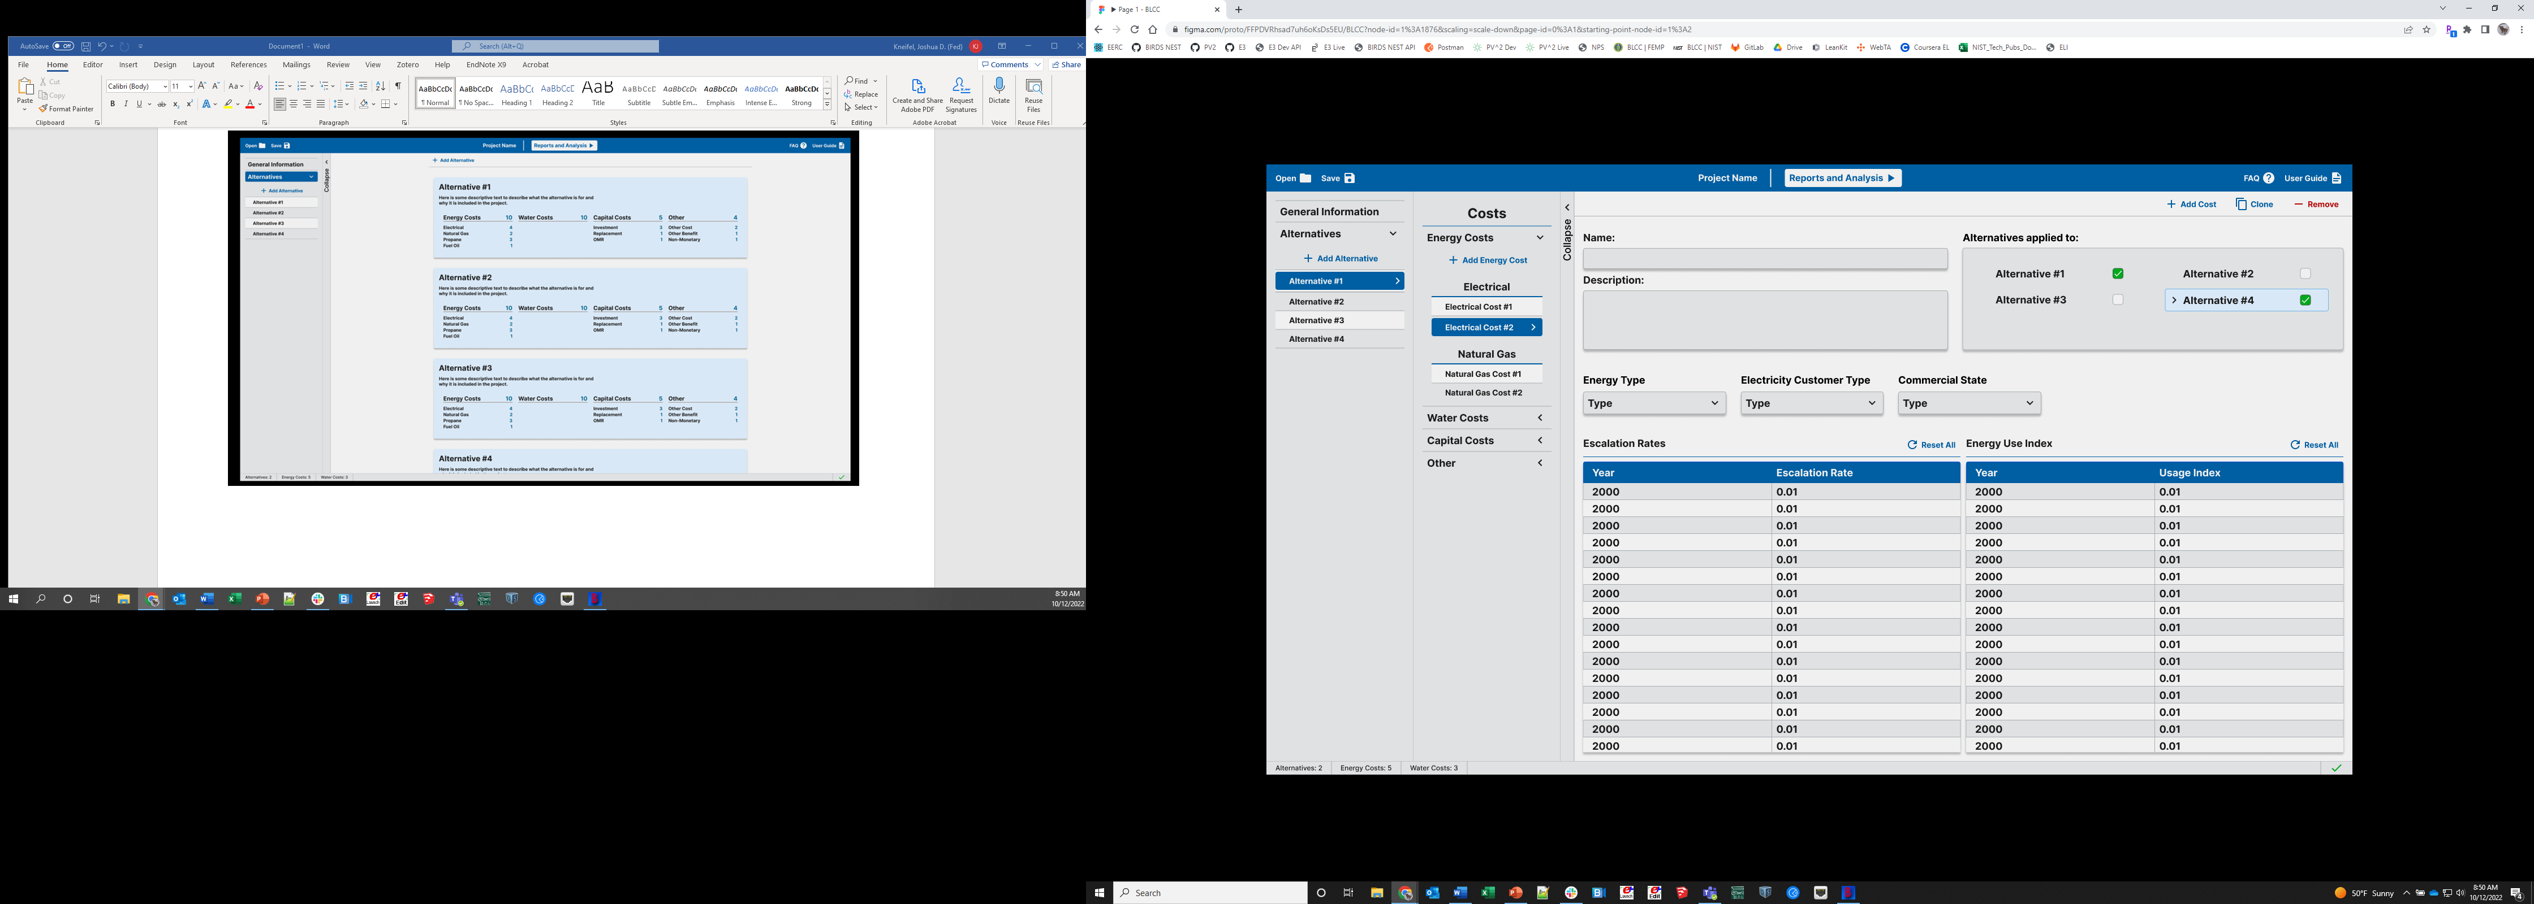

BLCC 5.3 provides results as text file reports like the first image below. BLCC 6.0 will provide results in both PDF and CSV file format. Additionally, BLCC will provide results within the tool. The user must navigate to the results section of the tool by clicking on the “Reports and Analysis” button in the middle of the header. Unlike BLCC 5.3, which calculates the results within the tool instantaneously, BLCC 6.0 communicates with NIST’s Economic Evaluation Engine (E3) API to calculate the results. Therefore, the user must click on the Run button of the Results section. The 7 different reports in BLCC have been condensed to 4: Inputs, Annual Results, Results by Alternative, and Summary. The **Inputs Page** provides the same information as the Inputs Report in BLCC 5.3, which is a print out of all the assumptions and inputs provided by the user, the file name, and date/time the analysis was completed.

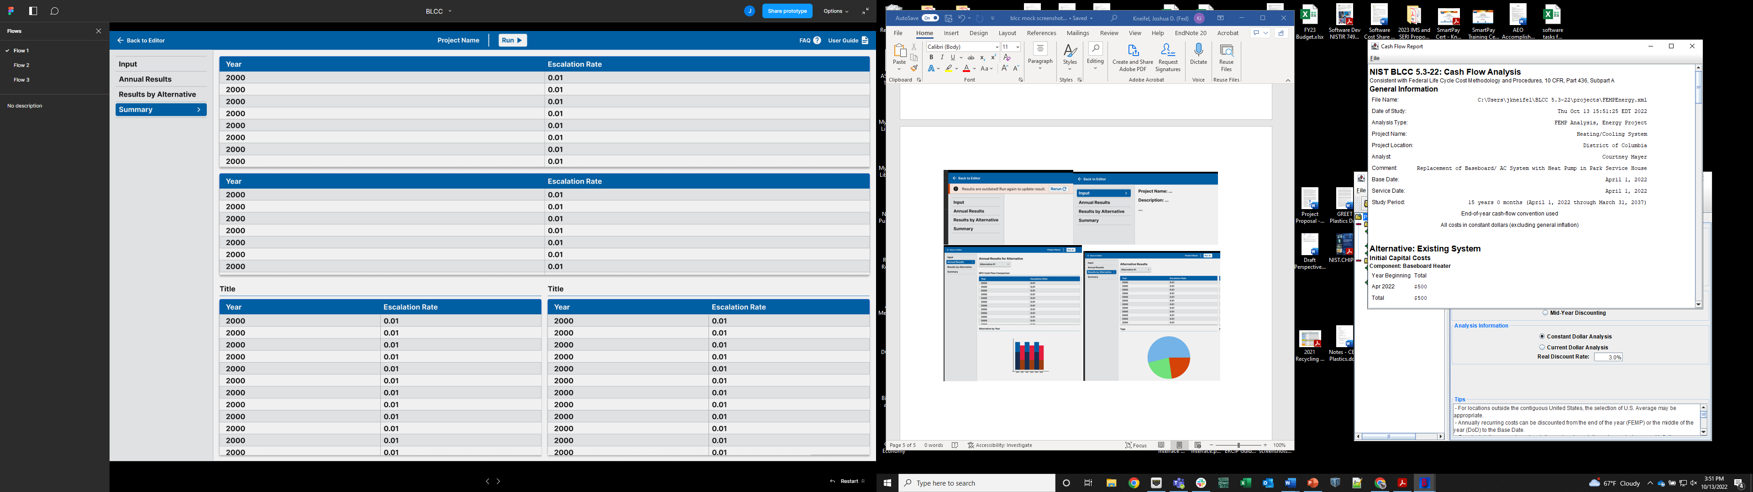

The **Annual Results Page** provides a detailed breakdown of the costs by year for each alternative. It will include both tables and graphs of both aggregated results comparing alternatives as well as costs by category for a selected alternative. This replaces the Cash Flow Report from BLCC 5.3.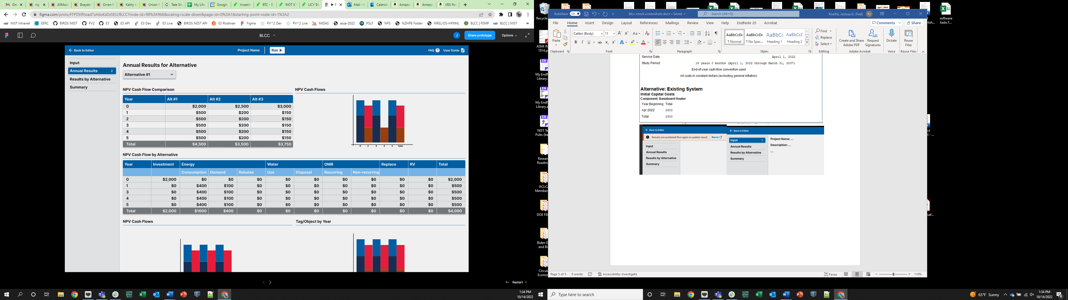

The **Results by Alternative Page** will provide life cycle results by category for the selected alternative in both tables and graphs. This replaces the Detailed LCC Report from BLCC 5.3.

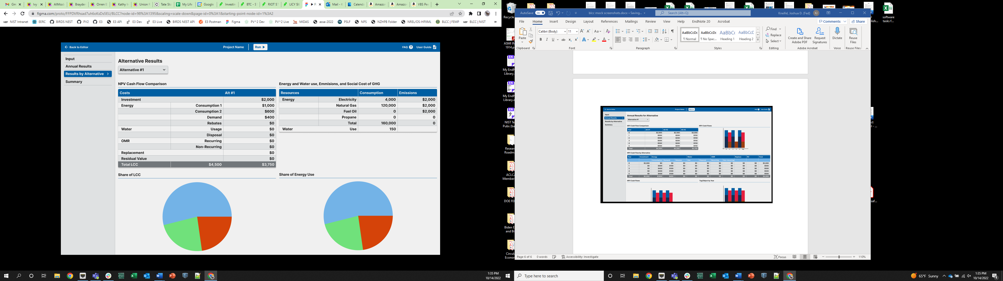

The **Summary Page** will provide life cycle results by alternative and compare those results to provide all the common life cycle cost metrics (NPV, NS, SIR, AIRR, etc.). Additionally, the results will also include GHG emissions and Social Cost of Carbon. LCCA results will be provided including and excluding SCC to provide flexibility for the users. This replaces the Summary LCC, Lowest LCC, and Comparative Analysis Reports from BLCC 5.3. 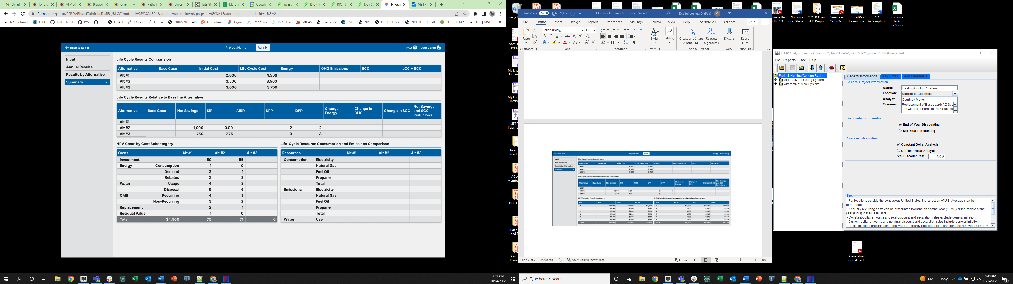

If a user wants to make a change to their analysis, they must navigate back to the project editor. If the analysis can already been run and the user makes a change, the tool will warn the user that the results may not match the user inputs and that the results should be rerun.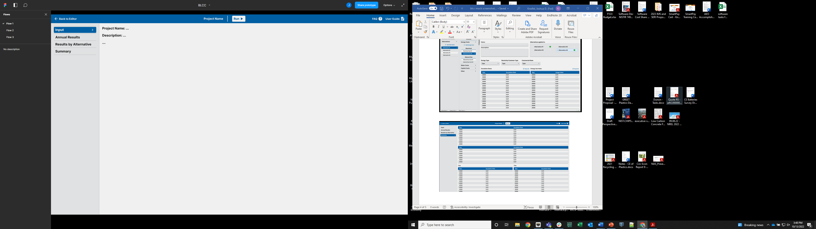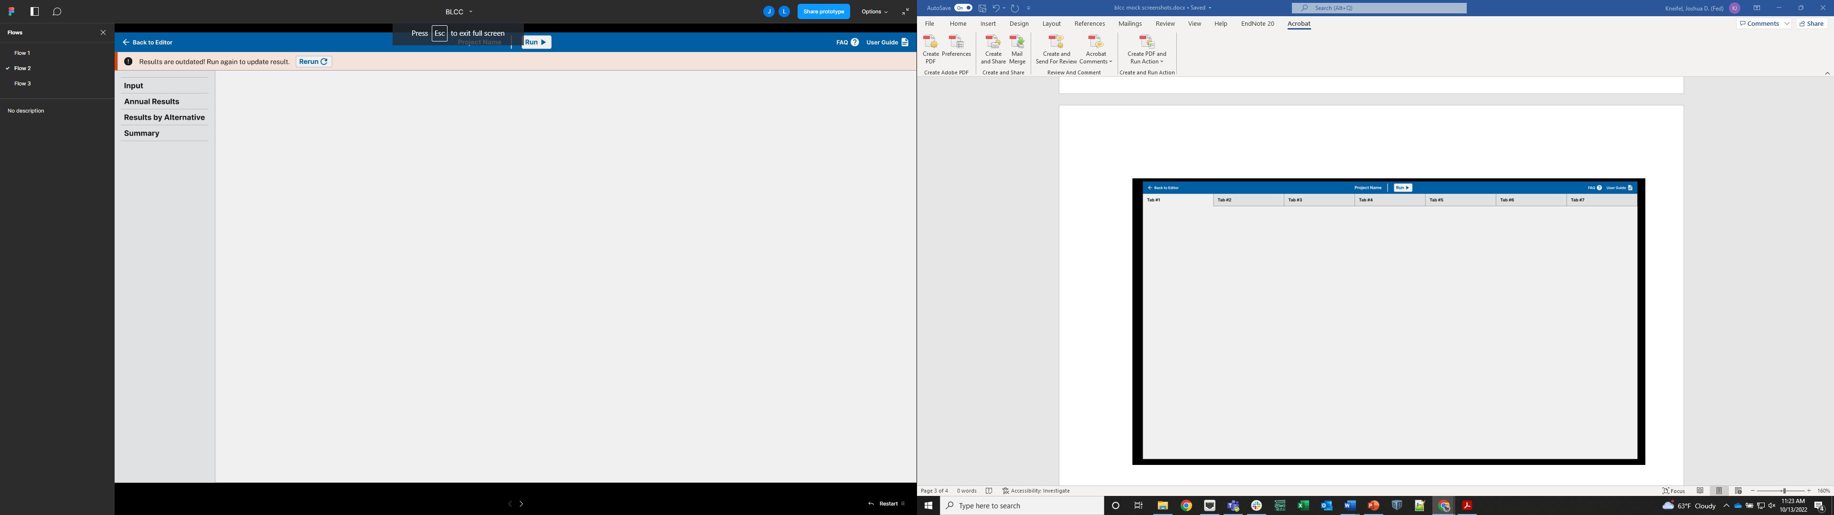

Other changes that are worth noting:

Neither BLCC 6.0 (user interface) or E3 (calculation API) stores any user information. A user can save their projects locally and upload them when they want to modify their projects and run analysis. The purpose of not providing cloud storage for users is threefold: (1) avoid saving federal information outside the user’s network (reduces security concerns) and (2) avoid the additional recurring cost of maintaining that cloud service to minimize the cost of maintaining the software, and (3) simplify initial design of the software.

Every time a user clicks Run, the BLCC file will be saved to the desired local path selected by the user and the results will be saved under the same file name with a PDF and CSV extension. This ensures the results files match the project file at all times and the users can simply open their results file(s) instead of having to open the web application to rerun their results.

We will have discussions with federal agencies when we begin development, particularly the military, to ensure the software meets their requirements for use on their networks. Any assistance related to this effort would be greatly appreciated.

We are re-assessing the templates and example files to determine the most useful ones to include/exclude/add in BLCC 6.0.

General expected timeline from the transition:

FY24: Begin development of BLCC 6.0 Oct 2023; BLCC 5.3-23 released; BLCC 5.3-24 released April 2024; BLCC 6.0 Beta version complete in September 2024

FY25: Internal and supervised beta testing early 2025; Public facing beta version in April 2025; External beta testing and validation late 2025

FY26: BLCC 6.0 officially replaces BLCC 5.3 in April 2026; BLCC 5.3 no longer updated or supported